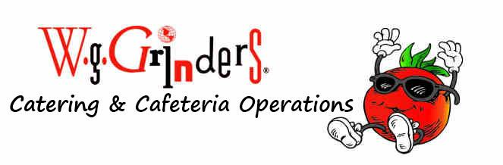

A LA CARTE ITEMS:

Pudding Parfait $3 Drinks:
Yogurt Parfait $3 Lg. Water $1.50
Veggie Cup $2.50 Sm. Water $.75
Fresh Fruit Cup $2.50 Milk $.75
String Cheese $.75 Gatorade $2
Uncrustable $3 (12oz)
Capri Sun $1
Baked Cookies $1
Rice Krispie Treats $1.50
Chewy Granola Bar $.75
Mott's Fruit Snacks $.50
Fruit Roll Ups $1

Variety Chips $1-$2
Mandarin Orange $.75
Banana $.75
Apple $1

